TIME
Pearson Edexcel – Thursday 4 June 2020 - Paper 2 (Calculator) Higher Tier
1.
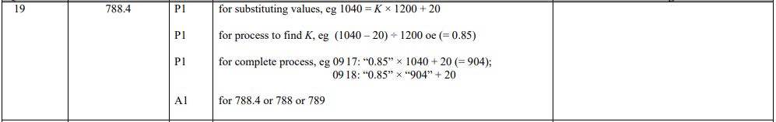
Pearson Edexcel – Monday 8 June 2020 - Paper 3 (Calculator) Higher Tier
2.
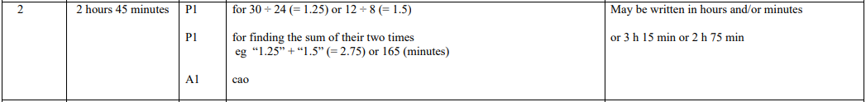
Pearson Edexcel - Tuesday 11 June 2019 - Paper 3 (Calculator) Higher Tier
3.
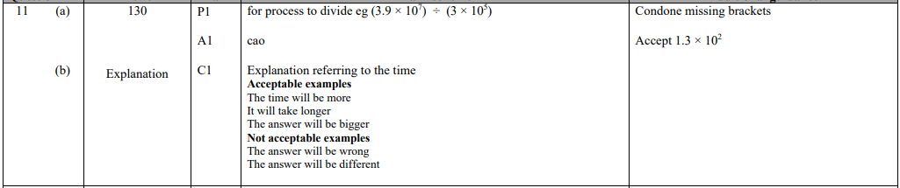
Pearson Edexcel - Tuesday 6 November 2018 - Paper 1 (Non-Calculator) Higher Tier
4.
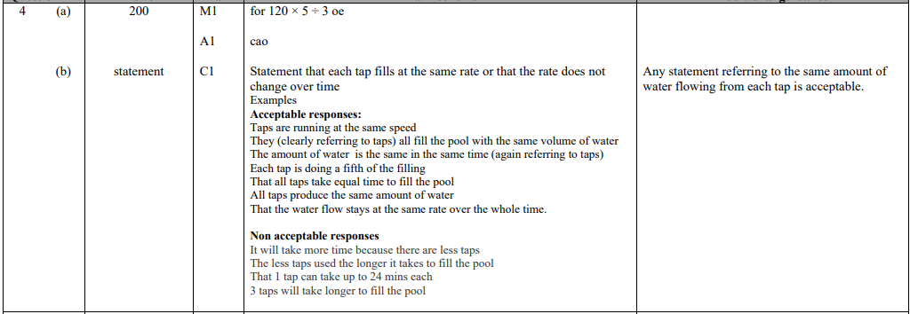
Pearson Edexcel - Monday 12 November 2018 - Paper 3 (Calculator) Higher Tier
5.
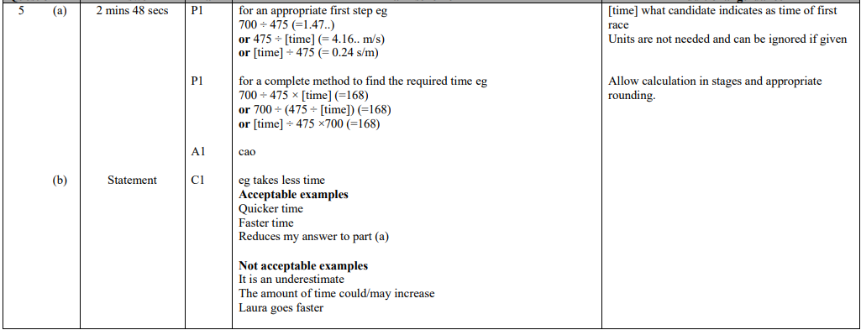
Pearson Edexcel - Tuesday 12 June 2018 - Paper 3 (Calculator) Higher Tier
6.
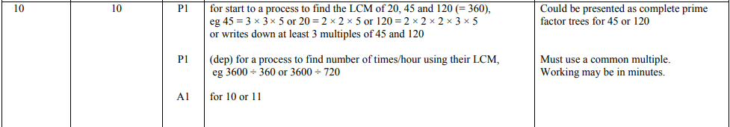
Pearson Edexcel - Friday 7 November 2014 - Paper 2 (Calculator) Higher Tier
7.
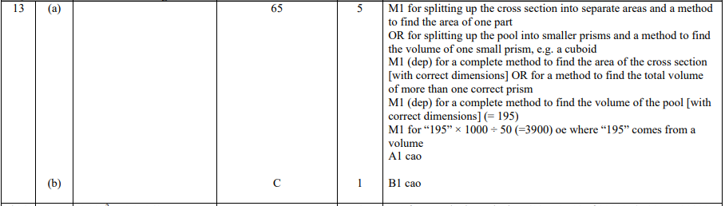
Pearson Edexcel - Friday 13 June 2014 - Paper 2 (Calculator) Higher Tier
8.
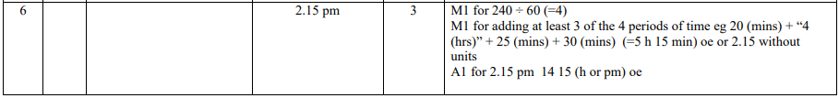
Pearson Edexcel - Tuesday 11 June 2013 - Paper 1 (Non-Calculator) Higher Tier
9.
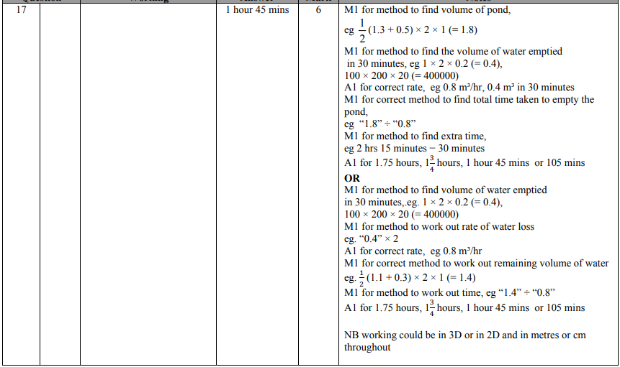
Pearson Edexcel - Friday 14 June 2013 - Paper 2 (Calculator) Higher Tier
10.
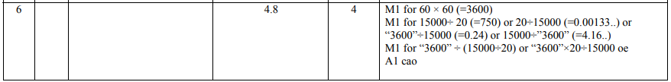
Pearson Edexcel - Thursday 28 February 2013 - Paper 1 (Non-Calculator) Higher Tier
11.
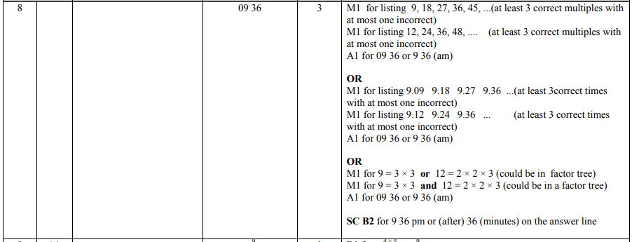
Pearson Edexcel - Thursday 8 November 2012 - Paper 2 (Calculator) Higher Tier
12.
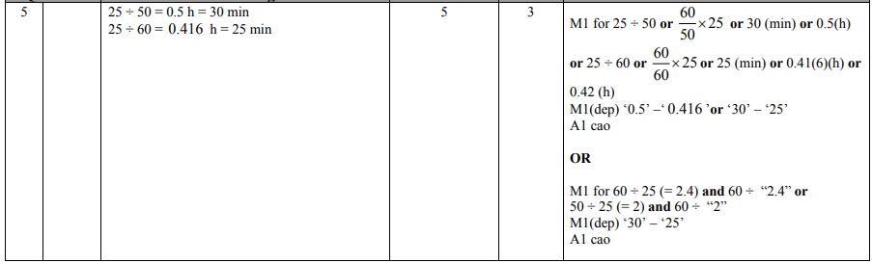
Pearson Edexcel - Monday 11 June 2012 - Paper 1 (Non-Calculator) Higher Tier
13.
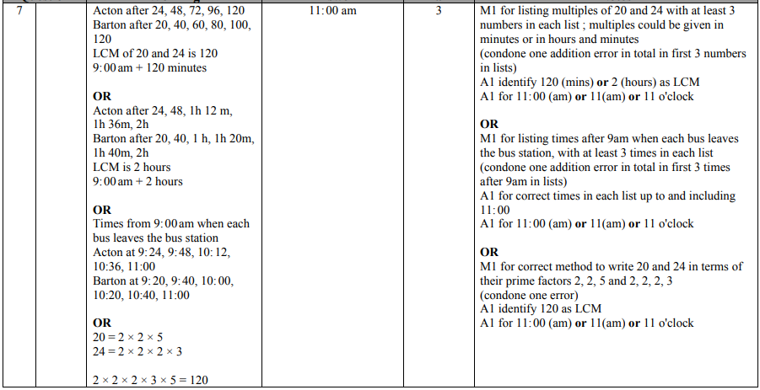
Pearson Edexcel - Wednesday 9 November 2011 - Paper 3 (Non-Calculator) Higher Tier
14.
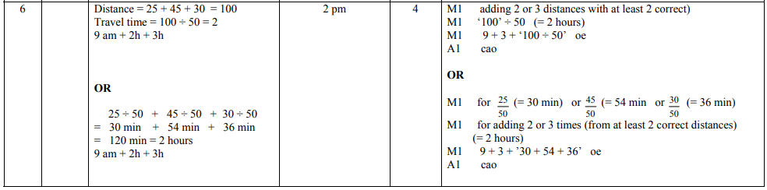
OCR GSCE – Thursday 5 November 2020 – Paper 5 (Non-Calculator) Higher Tier
15.
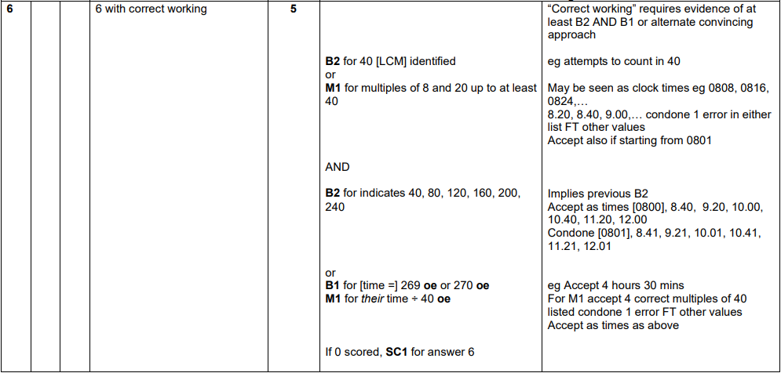
OCR GSCE – Tuesday 21 May 2019 – Paper 4 (Calculator) Higher Tier
16.
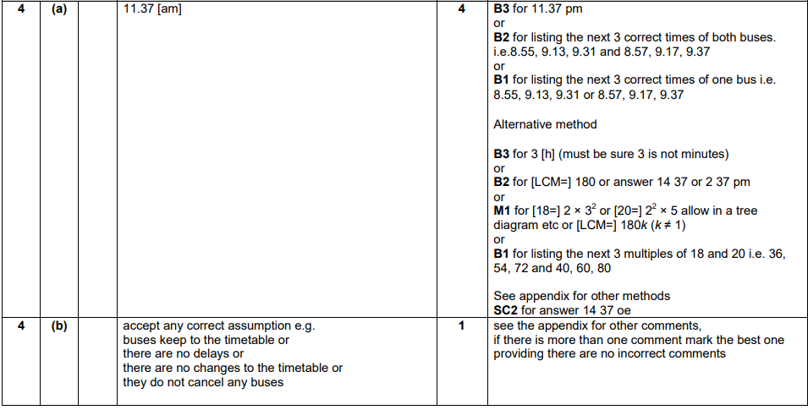

OCR GSCE – Sample Papers – Paper 6 (Calculator) Higher Tier
17.
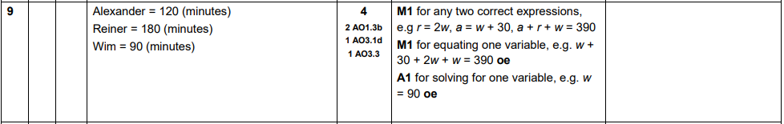
AQA GSCE – Monday 12 November 2018 – Paper 3 (Calculator) Higher Tier
18.
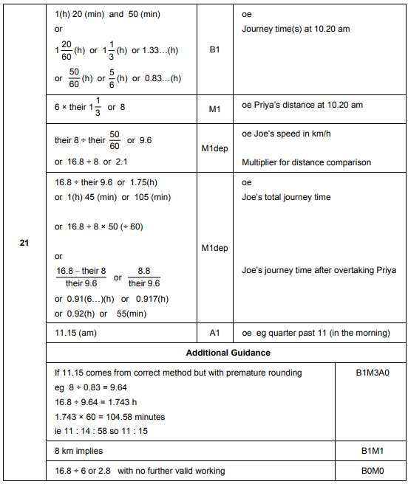
AQA GSCE – Thursday 2 November 2017 – Paper 1 (Non - Calculator) Higher Tier
19.
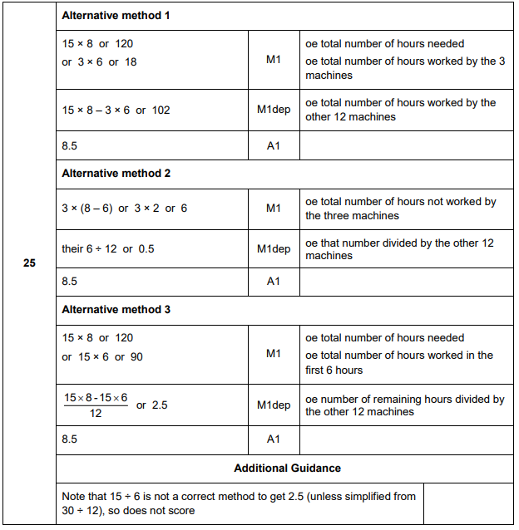

AQA GSCE – Wednesday 8 November 2017 – Paper 3 (Calculator) Higher Tier
20.
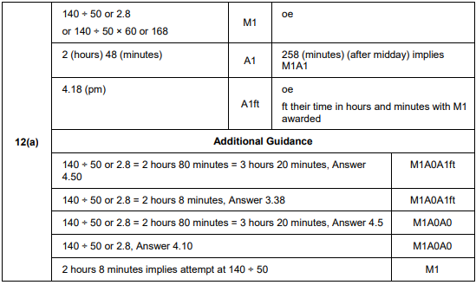
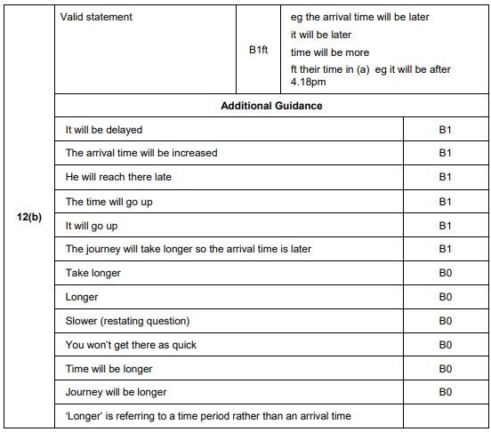
AQA GSCE – Sample Paper 1 (Non - Calculator) Higher Tier
21.
